Business Model Canvas Template & Example

Business Model Canvas Template
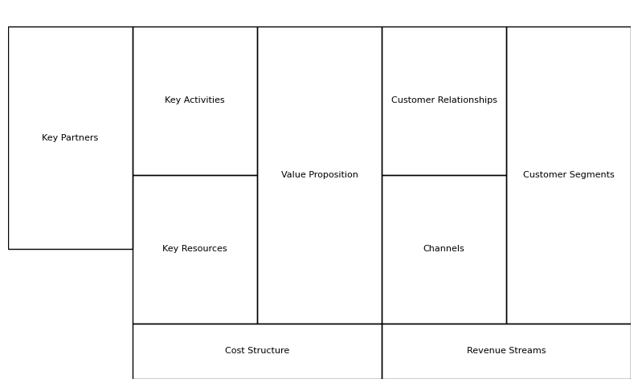
Key Partners | ____________________________________
Key Activities | ____________________________________
Key Resources | ____________________________________
Value Proposition | ____________________________________
Customer Relationships | ____________________________________
Channels | ____________________________________
Customer Segments | ____________________________________
Cost Structure | ____________________________________
Revenue Streams | ____________________________________

Business Model Canvas Example – EcoHome Essentials
Key Partners | Eco-friendly suppliers, shipping providers, influencers
Key Activities | Product sourcing, ecommerce operations, marketing
Key Resources | Website, inventory, supplier network, brand
Value Proposition | Affordable sustainable household products
Customer Relationships | Email marketing, loyalty programs, customer support
Channels | Website, social media, email, online marketplaces
Customer Segments | Eco-conscious consumers and families
Cost Structure | Inventory, shipping, marketing, website costs
Revenue Streams | Online product sales and subscription boxes

